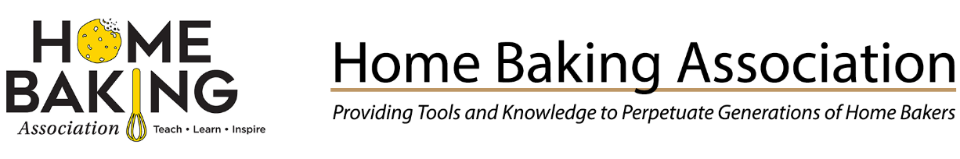Baking and Milling Careers Resources: Access baking, milling, sugar, thermometer, vanilla, wheat, yeast, industry partners and career resources.
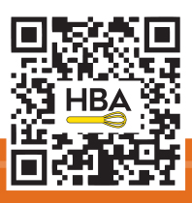
https://www.homebaking.org/
- Home Baking Association’s industry members- https://www.homebaking.org/members/
https://www.homebaking.org/associate-members/
- Home Baking Association partners- https://www.homebaking.org/partners/
Career Ready Practices, Education Standards and Clusters Access at LeadFCS Education- https://www.leadfcsed.org/career-clusters.html#/
- Advance CTE Career Clusters Framework, https://careertech.org/career-clusters/
- National FCS Education Standards (2018-2028) https://www.leadfcsed.org/national-standards.html#/
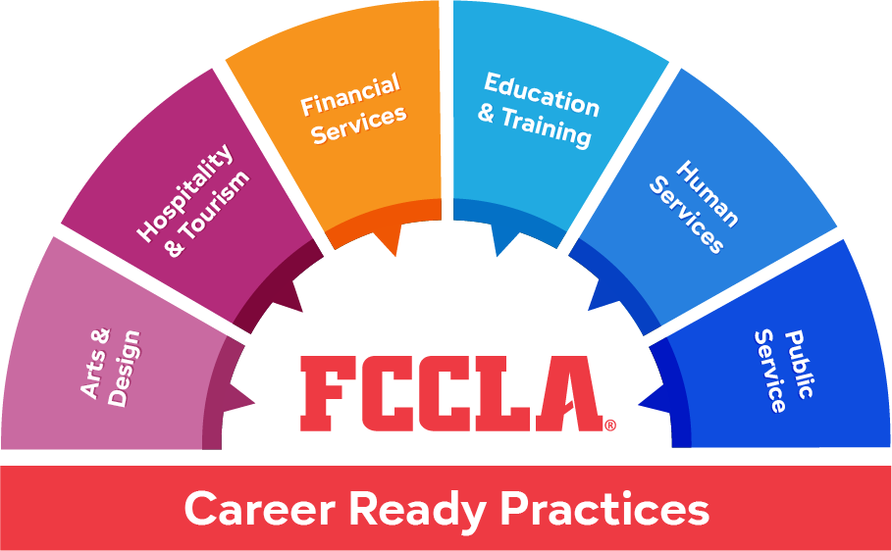
https://fcclainc.org/engage/career-clusters
https://fcclainc.org/clusters
Careers in Baking:
- American Society of Baking (ASBE) https://asbe.org/
- Baking Works, American Bakers Association (ABA) https://www.bakingworks.org/career-paths
- Career Paths Flow Chart https://static1.squarespace.com/static/63d3e2aecb3f040ad49e3b44/t/66101cf6b2b8ab4c207cb4c4/1712332024341/Baking+Works_Industry+Career+Paths.pdf
- Baker’s National Education Foundation (BNEF) - https://www.futureinbaking.com/ #futureinbaking #bakeacareer
- Kansas State U.- Grain and Food Science | K-State | Kansas State University
Videos, https://youtu.be/yriXDfZfp1o
Kansas state university grain science careers - Search Videos
- Retail Bakers of America (RBA) About, Certification, Resources, and Events https://www.retailbakersofamerica.org/home

Career Tools, Opportunities, Featured Companies- https://careers.retailbakersofamerica.org/
Careers in Milling:
- Grain Milling Career Network https://www.grainmillingcareers.com/career/
Career Quiz https://www.grainmillingcareers.com/quiz/
- Kansas State U.- https://www.grains.k-state.edu/academics/milling-science-management/
Video- https://youtu.be/4zbOg-qVpJU

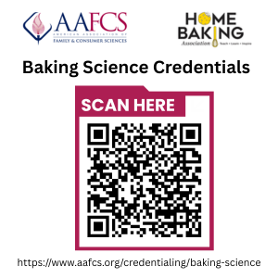
NEW! Baking Science Credentials for Students and Professionals:
The American Association of Family & Consumer Sciences (AAFCS) has partnered with wheat, milling and baking industry members of the Home Baking Association (HBA) to develop national Industry-Based Baking Science Credentials for FCS students and professionals.

- Careers  - Food Safety & Sanitation  - Baking Lab Equipment  - Baking Math | - Baking Ingredients  - Baking Techniques  - Baking Food Science
The Baking Science credentials validate knowledge and skills in the areas of:

The Baking Science credentials include:
- Pre-Professional Certification (Pre-PAC) in Baking Science Fundamentals
- Certified Baking Science Professional (CBSP)
Contact: AAFCS Credentialing Center at certification@aafcs.org or call 571-534-4082.


Baking Educator Resource Guide https://www.homebaking.org/wp-content/uploads/2025/06/Baking-Resources-061025.pdf
Baking Educator’s E-news archive https://www.homebaking.org/newsletter/
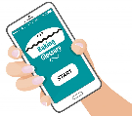Baking Glossary of Terms and Techniques live-linked to videos, industry
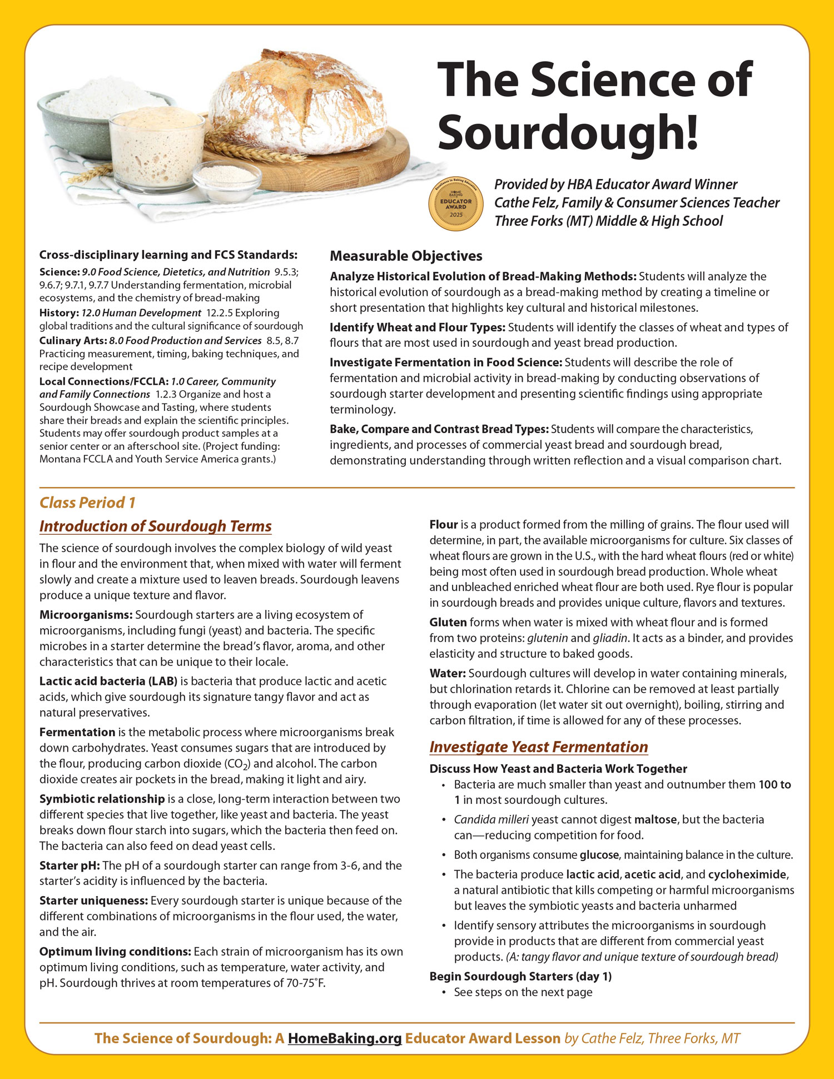
Educator award winning Lessons, FCS standards aligned – NEW Sourdough Science https://www.homebaking.org/lesson-plans/
A Baker’s Dozen Labs Manual- 13 labs featuring baking terms, techniques, baking science experiments, infographics for wheat, milling, yeast, baking careers, temperatures, rubrics and much more. Three levels of classroom tested baking recipes using volume and scaling and community and career connections. FACS and CTE standards aligned.
- Sold through AAFCS Curriculum Library
Baking Math resources- Baking Math Videos
- Baking with Sugar, Farm to Table- STEAM lessons, Infographics- https://www.homebaking.org/baking-education/
- Chef Kristen Hoffman – Learning Tracks, Baking School, Videos- https://bakerbettie.com/
- Chef Gemma Stafford - https://www.biggerbolderbaking.com/
- Chef Martin Earl, Culinary Editor, Thermoworks.com- https://www.thermoworks.com/webinar-series/
- Eat Wheat by Kansas Wheat, recipes, wheat resources, teaching aides, https://eatwheat.org/
- King Arthur Baking guides, volume and weights recipes https://www.kingarthurbaking.com/learn/guides
- Yeast Science, Step-by-Step and Blogger videos, https://redstaryeast.com/baking-with-yeast-guide/
Contact Home Baking Association: Aimee Soller, HBA President- president@homebaking.org

