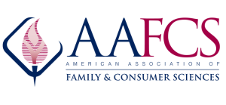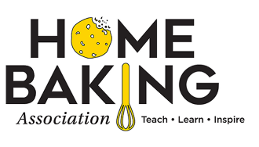
Build an FCS/CTE baking bridge from “home to career” through FCS! HomeBaking.org
Industry-Based Baking Credentials
for FCS students and professionals developed by wheat, milling and baking industry and FCS professionals.

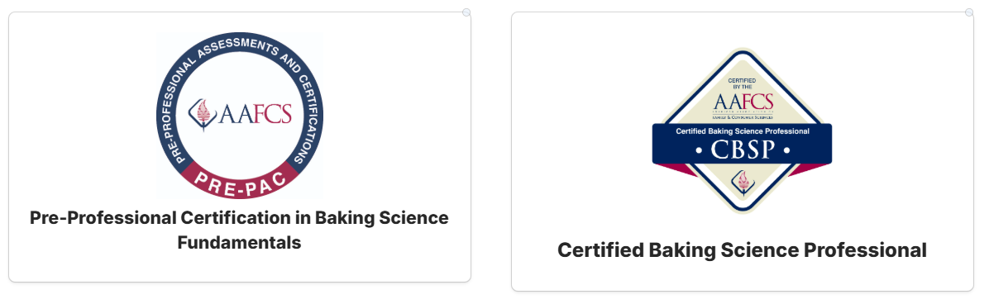

Both Baking Science Certification competency assessments include
1. Careers
Visit certification@aafcs.org
2. Food Safety & Sanitation
3. Baking Lab Equipment
4. Baking Math
5. Baking Ingredients
6. Baking Techniques
7. Baking Science
.

AAFCS contact: Lori Myer, PhD. – 571-534-4082. Home Baking Association contacts:
- Sharon Davis, FCS Baking Education consultant- hbadavis@gmail.com
- Robert Harper, HBA VP Programs- robertharper@hesenergy.net
- Aimee Soller, HBA President- president@homebaking.org

